**Customer Management**

|  |  |  |  |  |  |
| --- | --- | --- | --- | --- | --- |
| **Table Name** | **Field Name** | **Data Type** | **Length** | **Constraints** | **Description** |
| Customer | CustomerID | INT | - | Primary Key, Not Null, Auto Increment | Primary Key |
|  | FirstName | VARCHAR | 100 | Not Null | Customer's first name |
|  | LastName | VARCHAR | 100 | Not Null | Customer's last name |
|  | Email | VARCHAR | 255 | Not Null, Unique | Customer's email address |
|  | PhoneNumber | VARCHAR | 11 | Not Null | Customer's phone number |
|  | AddressLine1 | VARCHAR | 255 | Not Null | Primary address line |
|  | AddressLine2 | VARCHAR | 255 | Null | Secondary address line |
|  | City | VARCHAR | 100 | Not Null | City of residence |
|  | PostalCode | VARCHAR | 20 | Not Null | Postal code |
|  | RegistrationDate | DATE | - | Not Null | Date of registration |

**Product and Stock Management**

|  |  |  |  |  |  |  |  |  |
| --- | --- | --- | --- | --- | --- | --- | --- | --- |
| **Table Name** | | **Field Name** | | **Data Type** | | **Length** | **Constraints** | **Description** |
| Product | | ProductID | | INT | |  | Primary Key, Not Null, Auto Increment | Primary Key |
|  | | ProductName | | VARCHAR | | 255 | Not Null | Name of the product |
|  | | CategoryID | | INT | |  | Foreign Key, Not Null | Foreign Key to Category |
|  | | BrandID | | INT | |  | Foreign Key, Not Null | Foreign Key to Brand |
|  | | UnitPrice | | DECIMAL | | 10,2 | Not Null | Price per unit |
|  | | TaxRateID | | INT | |  | Foreign Key, Not Null | Foreign Key to TaxRate |
|  | | ReorderLevel | | INT | |  | Not Null | Stock level to trigger reorder |
|  | | IsActive | | BOOLEAN | |  | Not Null | Indicates if the product is active |
| **Table Name** | **Field Name** | | **Data Type** | | **Length** | | **Constraints** | **Description** |
| Category | CategoryID | | INT | |  | | Primary Key, Not Null, Auto Increment | Primary Key |
|  | CategoryName | | |  |  | | --- | --- | | VARCHAR | | |  | | | 255 | | Not Null | Name of the category |

|  |  |  |  |  |  |
| --- | --- | --- | --- | --- | --- |
| **Table Name** | **Field Name** | **Data Type** | **Length** | **Constraints** | **Description** |
| Brand | BrandID | INT |  | Primary Key, Not Null, Auto Increment | Primary Key |
|  | BrandName | |  |  | | --- | --- | | VARCHAR | | |  | | 255 | Not Null | Name of the brand |

|  |  |  |  |  |  |
| --- | --- | --- | --- | --- | --- |
| **Table Name** | **Field Name** | **Data Type** | **Length** | **Constraints** | **Description** |
| TaxRate | TaxRateID | INT |  | Primary Key, Not Null, Auto Increment | Primary Key |
|  | TaxRate | |  |  | | --- | --- | | DECIMAL | | |  | | 5,2 | Not Null | Tax percentage applied |

|  |  |  |  |  |  |
| --- | --- | --- | --- | --- | --- |
| **Table Name** | **Field Name** | **Data Type** | **Length** | **Constraints** | **Description** |
| Stock | StockID | INT |  | Primary Key, Not Null, Auto Increment | Primary Key |
|  | ProductID | |  |  | | --- | --- | | INT | | |  | | 5,2 | Foreign Key, Not Null | Foreign Key to Product |
|  | WarehouseID | INT |  | Foreign Key, Not Null | Foreign Key to Warehouse |
|  | QuantityAvailable | INT |  | Not Null | Quantity available in stock |
|  | LastRestockedDate | DATE |  | Not Null | Date when stock was last restocked |

|  |  |  |  |  |  |
| --- | --- | --- | --- | --- | --- |
| **Table Name** | **Field Name** | **Data Type** | **Length** | **Constraints** | **Description** |
| Warehouse | WarehouseID | INT |  | Primary Key, Not Null, Auto Increment | Primary Key |
|  | WarehouseName | |  |  | | --- | --- | | VARCHAR | | |  | | 255 | Not Null | Name of the warehouse |
|  | Location | VARCHAR | 255 | Not Null | Location of the warehouse |
|  | ManagerID | INT |  | Foreign Key, Not Null | Foreign Key to Employee |

**Discount Management**

|  |  |  |  |  |  |
| --- | --- | --- | --- | --- | --- |
| **Table Name** | **Field Name** | **Data Type** | **Length** | **Constraints** | **Description** |
| Discount | DiscountID | INT |  | Primary Key, Not Null, Auto Increment | Primary Key |
|  | DiscountName | |  |  | | --- | --- | | VARCHAR | | |  | | 5,2 | Not Null | Name of the discount |
|  | StartDate | DATE |  | Not Null | Start date of the discount |
|  | EndDate | DATE |  | Not Null | End date of the discount |
|  | DiscountPercentage | |  | | --- | |  |  |  | | --- | | DECIMAL | | 5,2 | Not Null | Percentage of discount |
|  | DiscountType | |  | | --- | | VARCHAR |  |  | | --- | |  | | 50 | Not Null | Type of discount (e.g., Percentage, Flat) |

|  |  |  |  |  |  |
| --- | --- | --- | --- | --- | --- |
| **Table Name** | **Field Name** | **Data Type** | **Length** | **Constraints** | **Description** |
| ProductDiscount | ProductDiscountID | INT |  | Primary Key, Not Null, Auto Increment | Primary Key |
|  | ProductID | |  |  | | --- | --- | | INT | | |  | |  | Foreign Key, Not Null | Foreign Key to Product |
|  | DiscountID | INT |  | Foreign Key, Not Null | Foreign Key to Discount |

**Sales Management**

|  |  |  |  |  |  |
| --- | --- | --- | --- | --- | --- |
| **Table Name** | **Field Name** | **Data Type** | **Length** | **Constraints** | **Description** |
| SalesTransaction | TransactionID | INT |  | Primary Key, Not Null, Auto Increment | Primary Key |
|  | CustomerID | |  |  | | --- | --- | | INT | | |  | |  | Foreign Key (Nullable for Guest Customers) | Foreign Key to Customer, Nullable for Guest Customers |
|  | TransactionDate | DATE |  | Not Null | Date of transaction |
|  | PaymentMethodID | INT |  | Foreign Key, Not Null | Foreign Key to PaymentMethod |
|  | TotalAmount | DECIMAL | 10,2 | Not Null | Total amount before discounts |
|  | DiscountApplied | DECIMAL | 5,2 | Not Null | Discount applied to the transaction |
|  | FinalAmount | DECIMAL | 10,2 | Not Null | Final amount after discounts |

|  |  |  |  |  |  |
| --- | --- | --- | --- | --- | --- |
| **Table Name** | **Field Name** | **Data Type** | **Length** | **Constraints** | **Description** |
| SalesTransactionDetail | TransactionDetailID | INT |  | Primary Key, Not Null, Auto Increment | Primary Key |
|  | TransactionID | |  |  | | --- | --- | | INT | | |  | |  | Foreign Key, Not Null | Foreign Key to SalesTransaction |
|  | ProductID | INT |  | Foreign Key, Not Null | Foreign Key to Product |
|  | Quantity | INT |  | |  | | --- | | Not Null | | Quantity of product sold |
|  | UnitPrice | DECIMAL | 10,2 | Not Null | Price per unit |
|  | LineTotal | DECIMAL | 10,2 | Not Null | Total price for the line item |
| **Table Name** | **Field Name** | **Data Type** | **Length** | **Constraints** | **Description** |
| PaymentMethod | PaymentMethodID | INT |  | Primary Key, Not Null, Auto Increment | Primary Key |
|  | PaymentType | |  |  | | --- | --- | | VARCHAR | | |  | | 50 | Not Null | Type of payment (e.g., Cash, Credit Card, Mobile Payment) |

**Employee Management**

|  |  |  |  |  |  |
| --- | --- | --- | --- | --- | --- |
| **Table Name** | **Field Name** | **Data Type** | **Length** | **Constraints** | **Description** |
| Employee | EmployeeID | INT |  | Primary Key, Not Null, Auto Increment | Primary Key |
|  | FirstName | |  |  | | --- | --- | | VARCHAR | | |  | | 100 | Not Null | First name of the employee |
|  | LastName | VARCHAR | 100 | Not Null | Last name of the employee |
|  | RoleID | INT |  | Foreign Key, Not Null | Foreign Key to Role |
|  | Email | VARCHAR | 255 | Not Null | Employee's email address |
|  | PhoneNumber | VARCHAR | 11 | Not Null | Employee's phone number |
|  | HireDate | DATE |  | Not Null | Date of hire |

|  |  |  |  |  |  |
| --- | --- | --- | --- | --- | --- |
| **Table Name** | **Field Name** | **Data Type** | **Length** | **Constraints** | **Description** |
| Role | RoleID | INT |  | Primary Key, Not Null, Auto Increment | Primary Key |
|  | RoleName | |  |  | | --- | --- | | VARCHAR | | |  | | 100 | Not Null | Name of the role (e.g., Admin, Cashier, Manager) |

|  |  |  |  |  |  |
| --- | --- | --- | --- | --- | --- |
| **Table Name** | **Field Name** | **Data Type** | **Length** | **Constraints** | **Description** |
| AuditLog | LogID | INT |  | Primary Key, Not Null, Auto Increment | Primary Key |
|  | Action | |  |  | | --- | --- | | TEXT | | |  | |  | Not Null | Description of the action |
|  | PerformedBy | INT |  | Foreign Key to Employee, Not Null | Foreign Key to Employee |
|  | ActionTimestamp | TIMESTAMP |  | Not Null | Timestamp of the action |
|  | TableName | VARCHAR | 100 | Not Null | Name of the table affected |

**Report Generation**

|  |  |  |  |  |  |
| --- | --- | --- | --- | --- | --- |
| **Table Name** | **Field Name** | **Data Type** | **Length** | **Constraints** | **Description** |
| Report | ReportID | INT |  | Primary Key, Not Null, Auto Increment | Primary Key |
|  | ReportName | |  |  | | --- | --- | | VARCHAR | | |  | | 255 | Not Null | Name of the report |
|  | GeneratedBy | INT |  | Foreign Key to Employee | Foreign Key to Employee |
|  | GeneratedDate | DATE |  | Not Null | Date the report was generated |
|  | ReportType | VARCHAR | 50 | Not Null | Type of report (e.g., Daily, Monthly, Sales Summary) |
|  | ReportData | BLOB/JSON |  | Not Null | Data in the report (Blob or JSON) |

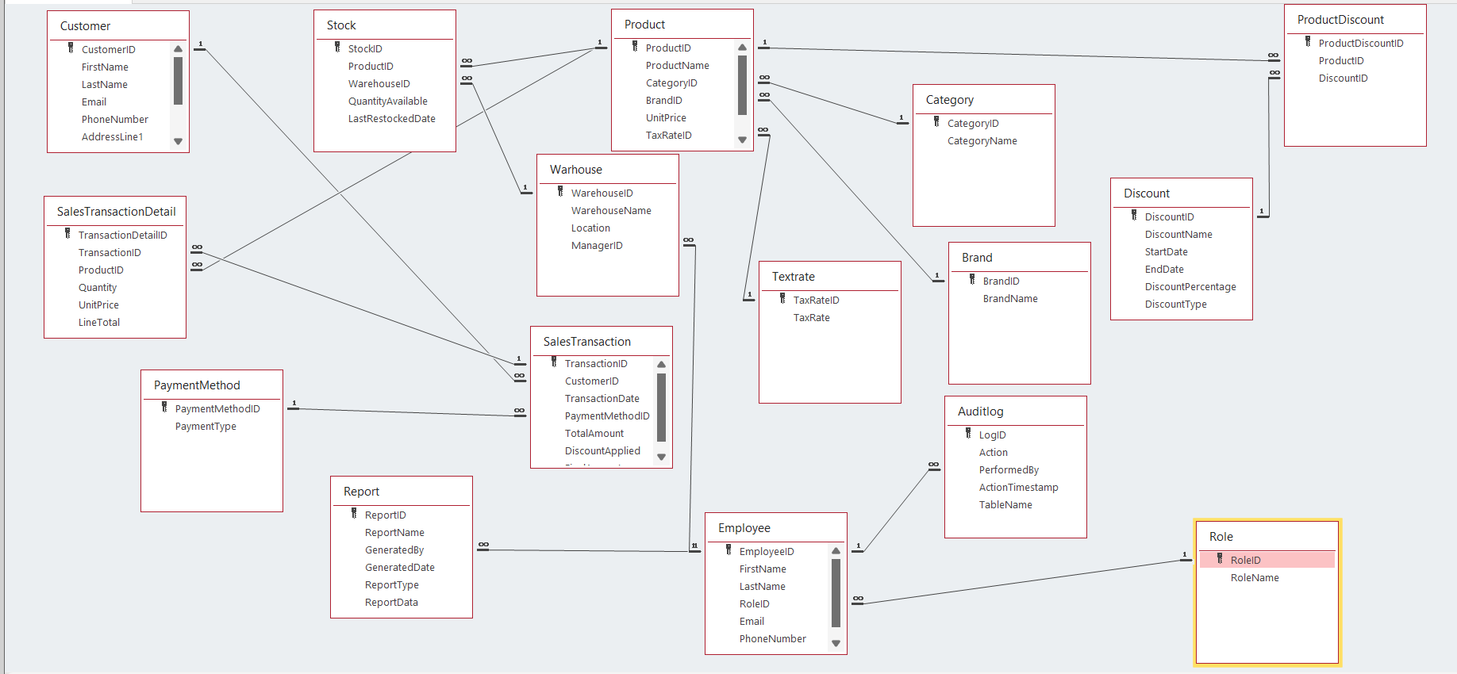Relationship